**Project Design Phase-II**

**Technology Stack (Architecture & Stack)**

|  |  |
| --- | --- |
| Date | 17 October 2022 |
| Team ID | PNT2022TMID06119 |
| Project Name | Skill and Job Recommender |
| Maximum Marks | 4 Marks |

**Technical Architecture:**

The Deliverable shall include the architectural diagram as below and the information as per the table1 & table

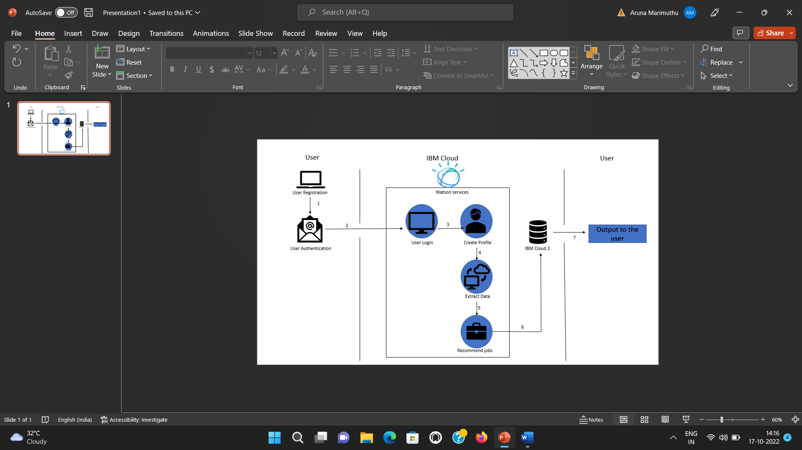

**Table-1 : Components & Technologies:**

|  |  |  |  |
| --- | --- | --- | --- |
| **S.No** | **Component** | **Description** | **Technology** |
|  | User Interface | Web Interface | HTML,CSS,Javascript. |
|  | Application Logic-1 | Prediction model | Python |
|  | Application Logic-2 | Extract data | IBM Watson Assistant |
|  | Database | Data Type-Dialog query | MySQL, NoSQL, etc. |
|  | Cloud Database | Database Service on Cloud | IBM DB2 |
|  | File Storage | For storing user data | IBM Block Storage or Local Filesystem |
|  | Infrastructure (Server / Cloud) | Cloud Server Configuration : Deploying the web interface using flask | Python flask. |

**Table-2: Application Characteristics:**

| **S.No** | **Characteristics** | **Description** | **Technology** |
| --- | --- | --- | --- |
|  | Open-Source Frameworks | IBM Watson | IBM Watson |
|  | Security Implementations | IBM Cloud | ISO,SOC2,US HIPAA,Encrypted file and storage system |
|  | Scalable Architecture | Web Interface Architecture:Intents,Entities,Dataflow,Scripts | IBM Watson Assistant |
|  | Availability | Load balancers,distributed Servers | IBM Watson Assistant |
|  | Performance | IBm Watson -Automated processs | IBM Watson |